Task 1:
% conda info

active environment : base
active env location : /opt/anaconda3
shell level : 1
user config file : /Users/lingyixu/.condarc
populated config files : /Users/lingyixu/.condarc
conda version : 24.7.1
conda-build version : 24.5.1
python version : 3.12.4.final.0
solver : libmamba (default)
virtual packages : __archspec=1=m1
__conda=24.7.1=0
__osx=14.6.1=0
__unix=0=0
base environment : /opt/anaconda3 (writable)
conda av data dir : /opt/anaconda3/etc/conda
conda av metadata url : None
channel URLs : https://repo.anaconda.com/pkgs/main/osx-arm64
https://repo.anaconda.com/pkgs/main/noarch
https://repo.anaconda.com/pkgs/r/osx-arm64
https://repo.anaconda.com/pkgs/r/noarch
package cache : /opt/anaconda3/pkgs
/Users/lingyixu/.conda/pkgs
envs directories : /opt/anaconda3/envs
/Users/lingyixu/.conda/envs
platform : osx-arm64
user-agent : conda/24.7.1 requests/2.32.2 CPython/3.12.4 Darwin/23.6.0 OSX/14.6.1 solver/libmamba conda-libmamba-solver/24.1.0 libmambapy/1.5.8 aau/0.4.4 c/. s/. e/.
UID:GID : 501:20
netrc file : None
offline mode : False

Task 2:
Code in IPython | Results
a = np.array([[1, 2, 3], [4, 5, 6]])  np.ndim(a) | 2
np.size(a) | 6
np.shape(a) | (2, 3)
n = 2  a.shape[n-1] | 3
np.array([[1., 2., 3.], [4., 5., 6.]]) | array([[1., 2., 3.],  [4., 5., 6.]])
a = np.array([[1, 2], [3, 4]])  b = np.array([[5, 6], [7, 8]])  c = np.array([[9, 10], [11, 12]])  d = np.array([[13, 14], [15, 16]])  np.block([[a, b], [c, d]]) | array([[ 1, 2, 5, 6],  [ 3, 4, 7, 8],  [ 9, 10, 13, 14],  [11, 12, 15, 16]])
a = np.array([1, 2, 3, 4, 5])  a[-1] | 5
a = np.array([[1, 2, 3, 4, 5], [6, 7, 8, 9, 10]])  a[1, 4] | 10
a[1, :] | array([ 6, 7, 8, 9, 10])
a[:5, :] | array([[ 1, 2, 3, 4, 5],  [ 6, 7, 8, 9, 10]])
a[-5:] | array([[ 1, 2, 3, 4, 5],  [ 6, 7, 8, 9, 10]])
a = np.array([[1, 2, 3, 4, 5, 56, 57, 58, 59], [6, 7, 8, 9, 10, 66, 67, 68, 69], [11, 12, 13, 14, 15, 76, 77, 78, 79],[16, 17, 18, 19, 20, 86, 87, 88, 89],[21, 22, 23, 24, 25, 96, 97, 98, 99]])  a[0:3, 4:9] | array([[ 5, 56, 57, 58, 59],  [10, 66, 67, 68, 69],  [15, 76, 77, 78, 79]])
a[np.ix_([1, 3, 4], [0, 2])] | array([[ 6, 8],  [16, 18],  [21, 23]])
a[2:21:2,:] | array([[11, 12, 13, 14, 15, 76, 77, 78, 79],  [21, 22, 23, 24, 25, 96, 97, 98, 99]])
a[::2, :] | array([[ 1, 2, 3, 4, 5, 56, 57, 58, 59],  [11, 12, 13, 14, 15, 76, 77, 78, 79],  [21, 22, 23, 24, 25, 96, 97, 98, 99]])
a[::-1,:] | array([[21, 22, 23, 24, 25, 96, 97, 98, 99],  [16, 17, 18, 19, 20, 86, 87, 88, 89],  [11, 12, 13, 14, 15, 76, 77, 78, 79],  [ 6, 7, 8, 9, 10, 66, 67, 68, 69],  [ 1, 2, 3, 4, 5, 56, 57, 58, 59]])
a[np.r_[:len(a),0]] | array([[ 1, 2, 3, 4, 5, 56, 57, 58, 59],  [ 6, 7, 8, 9, 10, 66, 67, 68, 69],  [11, 12, 13, 14, 15, 76, 77, 78, 79],  [16, 17, 18, 19, 20, 86, 87, 88, 89],  [21, 22, 23, 24, 25, 96, 97, 98, 99],  [ 1, 2, 3, 4, 5, 56, 57, 58, 59]])
a.transpose() | array([[ 1, 6, 11, 16, 21],  [ 2, 7, 12, 17, 22],  [ 3, 8, 13, 18, 23],  [ 4, 9, 14, 19, 24],  [ 5, 10, 15, 20, 25],  [56, 66, 76, 86, 96],  [57, 67, 77, 87, 97],  [58, 68, 78, 88, 98],  [59, 69, 79, 89, 99]])
a.conj().transpose() | array([[ 1, 6, 11, 16, 21],  [ 2, 7, 12, 17, 22],  [ 3, 8, 13, 18, 23],  [ 4, 9, 14, 19, 24],  [ 5, 10, 15, 20, 25],  [56, 66, 76, 86, 96],  [57, 67, 77, 87, 97],  [58, 68, 78, 88, 98],  [59, 69, 79, 89, 99]])
a = np.array([[1, 2], [3, 4]])  b = np.array([[5, 6], [7, 8]])  a @ b | array([[19, 22],  [43, 50]])
a * b | array([[ 5, 12],  [21, 32]])
a/b | array([[0.2 , 0.33333333],  [0.42857143, 0.5 ]])
a**3 | array([[ 1, 8],  [27, 64]])
(a > 0.5) | array([[ True, True],  [ True, True]])
np.nonzero(a > 0.5) | (array([0, 0, 1, 1]), array([0, 1, 0, 1]))
v = np.array([0.2, 0.8])  a[:, np.nonzero(v > 0.5)[0]] | array([[2],  [4]])
a[:, v.T > 0.5] | array([[2],  [4]])
a = np.array([[0.2, 0.3, 0.4, 0.5], [1.2, 1.3, 1.4, 1.5], [0.6, 1.1, 0.1, 0.7]])  a[a < 0.5]=0  a | array([[0. , 0. , 0. , 0.5],  [1.2, 1.3, 1.4, 1.5],  [0.6, 1.1, 0. , 0.7]])
a * (a > 1) | array([[0. , 0. , 0. , 0. ],  [1.2, 1.3, 1.4, 1.5],  [0. , 1.1, 0. , 0. ]])
a[:] = 3  a | array([[3., 3., 3., 3.],  [3., 3., 3., 3.],  [3., 3., 3., 3.]])
b = a.copy()  b | array([[3., 3., 3., 3.],  [3., 3., 3., 3.],  [3., 3., 3., 3.]])
a = np.array([[0.2, 0.3, 0.4, 0.5], [1.2, 1.3, 1.4, 1.5], [0.6, 1.1, 0.1, 0.7]])  b = a[1, :].copy()  b | array([1.2, 1.3, 1.4, 1.5])
a.flatten() | array([0.2, 0.3, 0.4, 0.5, 1.2, 1.3, 1.4, 1.5, 0.6, 1.1, 0.1, 0.7])
np.arange(1., 11.) | array([ 1., 2., 3., 4., 5., 6., 7., 8., 9., 10.])
np.arange(10.) | array([0., 1., 2., 3., 4., 5., 6., 7., 8., 9.])
np.arange(1.,11.)[:, np.newaxis] | array([[ 1.],  [ 2.],  [ 3.],  [ 4.],  [ 5.],  [ 6.],  [ 7.],  [ 8.],  [ 9.],  [10.]])
np.zeros((3, 4)) | array([[0., 0., 0., 0.],  [0., 0., 0., 0.],  [0., 0., 0., 0.]])
np.zeros((3, 4, 5)) | array([[[0., 0., 0., 0., 0.],  [0., 0., 0., 0., 0.],  [0., 0., 0., 0., 0.],  [0., 0., 0., 0., 0.]],  [[0., 0., 0., 0., 0.],  [0., 0., 0., 0., 0.],  [0., 0., 0., 0., 0.],  [0., 0., 0., 0., 0.]],  [[0., 0., 0., 0., 0.],  [0., 0., 0., 0., 0.],  [0., 0., 0., 0., 0.],  [0., 0., 0., 0., 0.]]])
np.ones((3, 4)) | array([[1., 1., 1., 1.],  [1., 1., 1., 1.],  [1., 1., 1., 1.]])
np.eye(3) | array([[1., 0., 0.],  [0., 1., 0.],  [0., 0., 1.]])
np.diag(a) | array([0.2, 1.3, 0.1])
from numpy.random import default_rng  rng = default_rng(42)  rng.random((3, 4)) | array([[0.77395605, 0.43887844, 0.85859792, 0.69736803],  [0.09417735, 0.97562235, 0.7611397 , 0.78606431],  [0.12811363, 0.45038594, 0.37079802, 0.92676499]])
np.linspace(1,3,4) | array([1. , 1.66666667, 2.33333333, 3. ])
np.mgrid[0:9.,0:6.] | array([[[0., 0., 0., 0., 0., 0.],  [1., 1., 1., 1., 1., 1.],  [2., 2., 2., 2., 2., 2.],  [3., 3., 3., 3., 3., 3.],  [4., 4., 4., 4., 4., 4.],  [5., 5., 5., 5., 5., 5.],  [6., 6., 6., 6., 6., 6.],  [7., 7., 7., 7., 7., 7.],  [8., 8., 8., 8., 8., 8.]],  [[0., 1., 2., 3., 4., 5.],  [0., 1., 2., 3., 4., 5.],  [0., 1., 2., 3., 4., 5.],  [0., 1., 2., 3., 4., 5.],  [0., 1., 2., 3., 4., 5.],  [0., 1., 2., 3., 4., 5.],  [0., 1., 2., 3., 4., 5.],  [0., 1., 2., 3., 4., 5.],  [0., 1., 2., 3., 4., 5.]]])
np.ix_(np.r_[0:9.],np.r_[0:6.] | (array([[0.],  [1.],  [2.],  [3.],  [4.],  [5.],  [6.],  [7.],  [8.]]),  array([[0., 1., 2., 3., 4., 5.]]))
np.meshgrid([1,2,4],[2,4,5]) | [array([[1, 2, 4],  [1, 2, 4],  [1, 2, 4]]),  array([[2, 2, 2],  [4, 4, 4],  [5, 5, 5]])]
np.ix_([1,2,4],[2,4,5]) | (array([[1],  [2],  [4]]),  array([[2, 4, 5]]))
a = np.array([[ 1, 2, 3, 4],  [ 5, 6, 7, 8],  [ 9, 10, 11, 12]])  m = 1  n = 2  np.tile(a, (m, n)) | array([[ 1, 2, 3, 4, 1, 2, 3, 4],  [ 5, 6, 7, 8, 5, 6, 7, 8],  [ 9, 10, 11, 12, 9, 10, 11, 12]])
a = np.array([[1, 2, 3, 4], [5, 6, 7, 8]])  b = np.array([[11, 12, 13, 14], [15, 16, 17, 18]])  np.concatenate((a,b),1) | array([[ 1, 2, 3, 4, 11, 12, 13, 14],  [ 5, 6, 7, 8, 15, 16, 17, 18]])
np.concatenate((a,b)) | array([[ 1, 2, 3, 4],  [ 5, 6, 7, 8],  [11, 12, 13, 14],  [15, 16, 17, 18]])
a.max() | 8
a.max(0) | array([5, 6, 7, 8])
a.max(1) | array([4, 8])
np.maximum(a, b) | array([[11, 12, 13, 14],  [15, 16, 17, 18]])
np.linalg.norm(a) | 14.2828568570857
np.logical_and(a,b) | array([[ True, True, True, True],  [ True, True, True, True]])
np.logical_or(a,b) | array([[ True, True, True, True],  [ True, True, True, True]])
a & b | array([[1, 0, 1, 4],  [5, 0, 1, 0]])
a | b | array([[11, 14, 15, 14],  [15, 22, 23, 26]])
c = np.array([[9, 10], [11, 12]])  np.linalg.inv(c) | array([[-6. , 5. ],  [ 5.5, -4.5]])
np.linalg.pinv(c) | array([[-6. , 5. ],  [ 5.5, -4.5]])
np.linalg.matrix_rank(c) | 2
np.linalg.solve(c, b) | array([[ 9., 8., 7., 6.],  [-7., -6., -5., -4.]])
np.linalg.lstsq(a, b) | (array([[-2.3, -2.6, -2.9, -3.2],  [-0.6, -0.7, -0.8, -0.9],  [ 1.1, 1.2, 1.3, 1.4],  [ 2.8, 3.1, 3.4, 3.7]]),  array([], dtype=float64),  2,  array([14.22740741, 1.25732984]))
U, S, Vh = np.linalg.svd(a); V = Vh.T | In [94]: U  Out[94]:  array([[-0.37616823, -0.92655138],  [-0.92655138, 0.37616823]])  In [95]: S  Out[95]: array([14.22740741, 1.25732984])  In [96]: Vh  Out[96]:  array([[-0.35206169, -0.44362578, -0.53518987, -0.62675396],  [ 0.75898127, 0.3212416 , -0.11649807, -0.55423774],  [-0.40008743, 0.25463292, 0.69099646, -0.54554195],  [-0.37407225, 0.79697056, -0.47172438, 0.04882607]])
d = np.array([[5, 4], [3, 4]])  np.linalg.cholesky(d) | array([[2.23606798, 0. ],  [1.34164079, 1.4832397 ]])
D,V = np.linalg.eig(d) | In [106]: D  Out[106]: array([8., 1.])  In [107]: V  Out[107]:  array([[ 0.8 , -0.70710678],  [ 0.6 , 0.70710678]])
D,V = np.linalg.eig(a, b) | TypeError: eig() takes 1 positional argument but 2 were given  Do not know why.
D,V = eigs(a, k=3) | NameError: name 'eigs' is not defined;  module 'numpy' has no attribute 'eigs';  eig() got an unexpected keyword argument 'k';  Do not know how to deal with it.
Q,R = np.linalg.qr(a)  Q, R | (array([[-0.19611614, -0.98058068],  [-0.98058068, 0.19611614]]),  array([[-5.09901951, -6.27571632, -7.45241314, -8.62910995],  [ 0. , -0.78446454, -1.56892908, -2.35339362]]))
P,L,U = linalg.lu(a) | name 'linalg' is not defined;  module 'numpy.linalg' has no attribute 'lu'
cg | name 'cg' is not defined
np.fft.fft(a) | array([[10.+0.j, -2.+2.j, -2.+0.j, -2.-2.j],  [26.+0.j, -2.+2.j, -2.+0.j, -2.-2.j]])
np.fft.ifft(a) | array([[ 2.5+0.j , -0.5-0.5j, -0.5+0.j , -0.5+0.5j],  [ 6.5+0.j , -0.5-0.5j, -0.5+0.j , -0.5+0.5j]])
np.sort(a) | array([[1, 2, 3, 4],  [5, 6, 7, 8]])
np.sort(a, axis=1) | array([[1, 2, 3, 4],  [5, 6, 7, 8]])
I = np.argsort(a[:, 0]); b = a[I,:] | In [127]: I  Out[127]: array([0, 1])  In [128]: b  Out[128]:  array([[1, 2, 3, 4],  [5, 6, 7, 8]])
Z = np.array([  [1, 2],  [3, 4],  [5, 6]  ])  y = np.array([7, 8, 9])  x = np.linalg.lstsq(Z, y)  x | (array([-6. , 6.5]),  array([3.19835777e-30]),  2,  array([9.52551809, 0.51430058]))
x = np.array([9.52551809, 0.51430058])  q = 2  signal.resample(x, int(np.ceil(len(x)/2))) | array([5.01990934])
a = np.array([[1, 2, 3, 4], [5, 6, 7, 8]])  np.unique(x) | array([1, 2, 3, 4, 5, 6, 7, 8])
a = np.array([[[1, 2, 3], [4, 5, 6]]])  a.squeeze() | array([[1, 2, 3],  [4, 5, 6]])

Task 3:
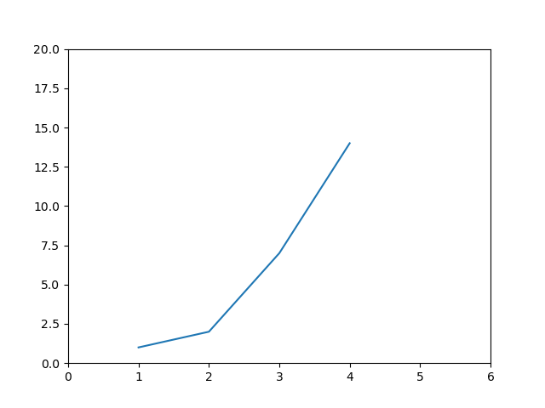

Task 4:
- Code:
```
import matplotlib.pyplot as plt

x = np.linspace(0, 10, 100)
y1 = np.sin(x)
y2 = np.cos(x)

plt.plot(x, y1, label='Sine Wave', color='blue', linestyle='-', linewidth=2)
plt.plot(x, y2, label='Cosine Wave', color='red', linestyle='--', linewidth=2)
plt.show()
```

- Figure:
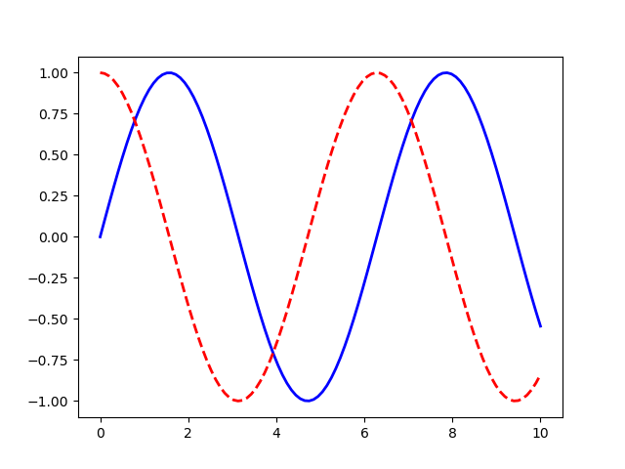

Task 5:
I prefer to use Github.
Account: Bei129
Name: Lingyi Xu
Email: lingyi.xu129@gmail.com

Task 6:
https://github.com/Bei129/Intro-to-Deep-Machine-Learning

